## **3.2 Behavior Modelling**

Behavioral Model refers to the use of data that are available and the use of data spend relevant by consumer and business for the estimation of future behavior.

### **3.2.1 Activity Diagram**

Activity diagram is a flowchart that represents actions and flow of control in a system. This diagram can also explain the steps that are in use case diagram.

The importance of performing activity diagram in my project are as follows:

* It helps in describing the logic of an operation.
* It records the logic of business in a simple way that makes easy in communicating the complexity of business logic with all the stake holders.
* It is simple in understanding for all the end users.

**Report of notations in Activity Diagram**

|  |  |  |
| --- | --- | --- |
| **Notation** | **Name** | **Function** |
|  | Start Point | It can be used by itself or with a note symbol that explains the starting point. |
|  | Swim Lane | It can be used to indicate which actors or objects are responsible. |
|  | Activity | These shapes indicate the activities the make up a modeled process. |
|  | Connector | It represented by arrowed lines that show the directional flow, or control flow of the activity. |
|  | Join | It combines two concurrent activities and re-introduces them to a flow where only activity occurs at a time. |
|  | Fork | It splits a single activity flow into two concurrent activities. |
|  | Decision | It represents the branching or merging of various flows with the symbol acting as a frame or container. |
|  | Receive Signal | Demonstrates the acceptance of an event. |
|  | Send Signal | A signal is being sent to receiving activity seen as above. |
|  | Accept Time Event | The flow for a time is stopped by time event which is illustrated by an hourglass. |
|  | Interruptible | The two standardized artifacts are groups and text annotations. |
|  | Activity Interrupt | It interrupts the flow denoted with a lightning bolt such as a cancellation. |
|  | Flow Final | It shows the ending point of a process flow. |
|  | End Symbol | It represents the completion of a process. |

**Login and Registration**

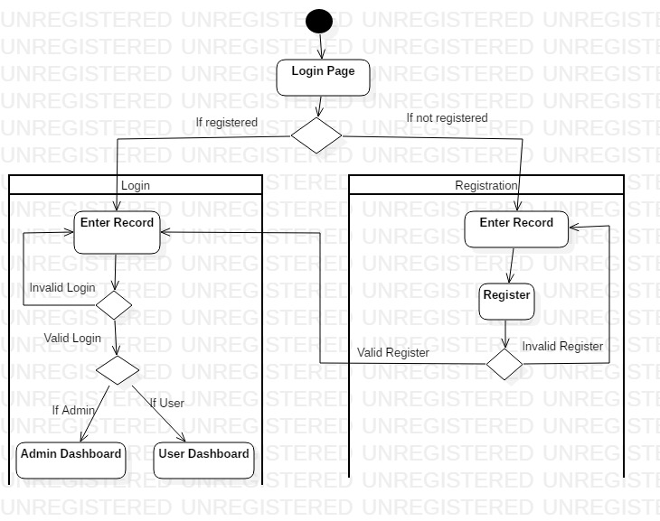

In the above activity diagram, the activity of the users starts from the login page. After entering the login page a decision notation will separate two different conditions for the registered and unregistered users. If the user is not registered, a registration form will be opened where the details will be provided by users, and if in case there is error in the registration form the user will be taken back to beginning and if the registration is valid the user will be taken to the login page. After the completion of the registration and if the user is registered from the first the user will enter the login page where the successful login will take the user to the admin or user dashboard according to the role they have in the database and the login is unsuccessful the user will be taken back to the beginning of the login page.

**Admin Dashboard**

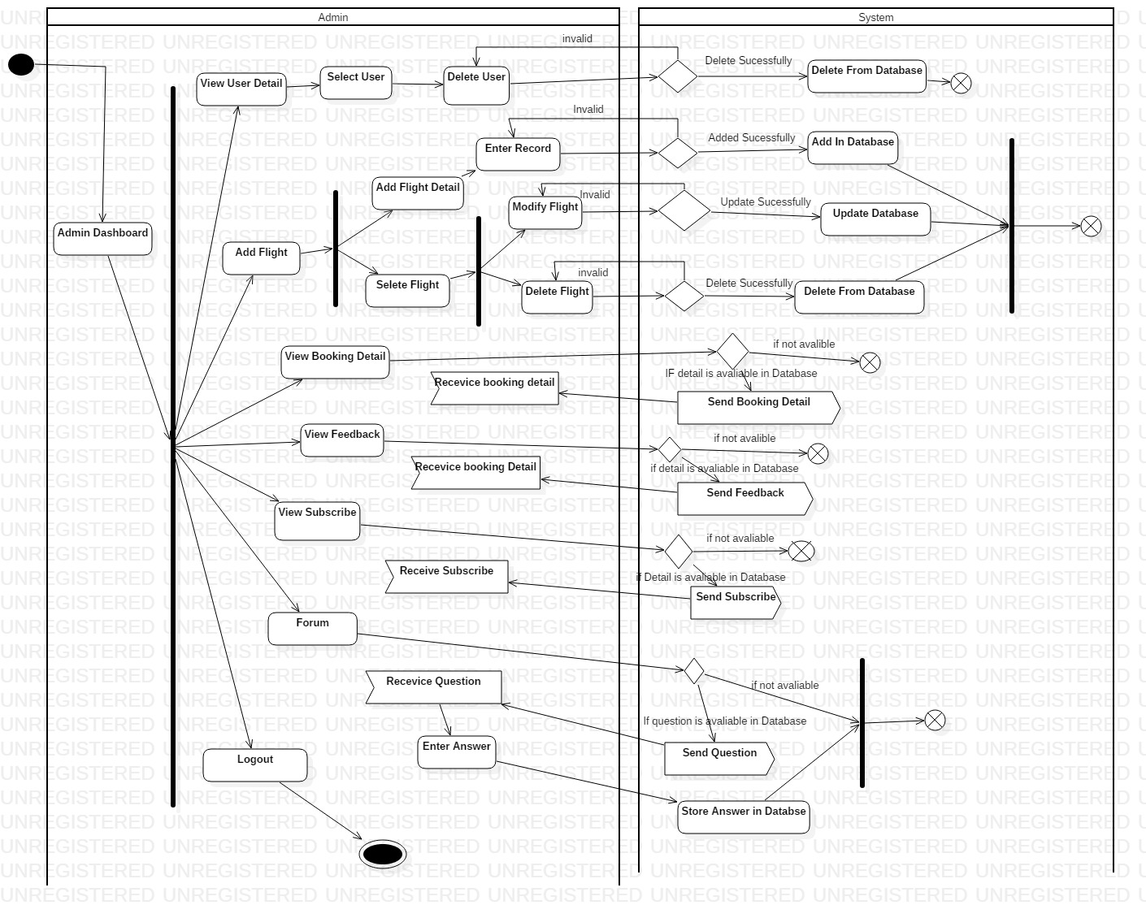

When the user is taken into the admin dashboard after the successful login, admin can perform various tasks as illustrated by the fork notation. Briefly, admin can change the profile of the user and can make changes in the database with permission from the system. Admin can view booking detail, feedback, subscribe, receive questions and enter answers.

**User Dashboard**

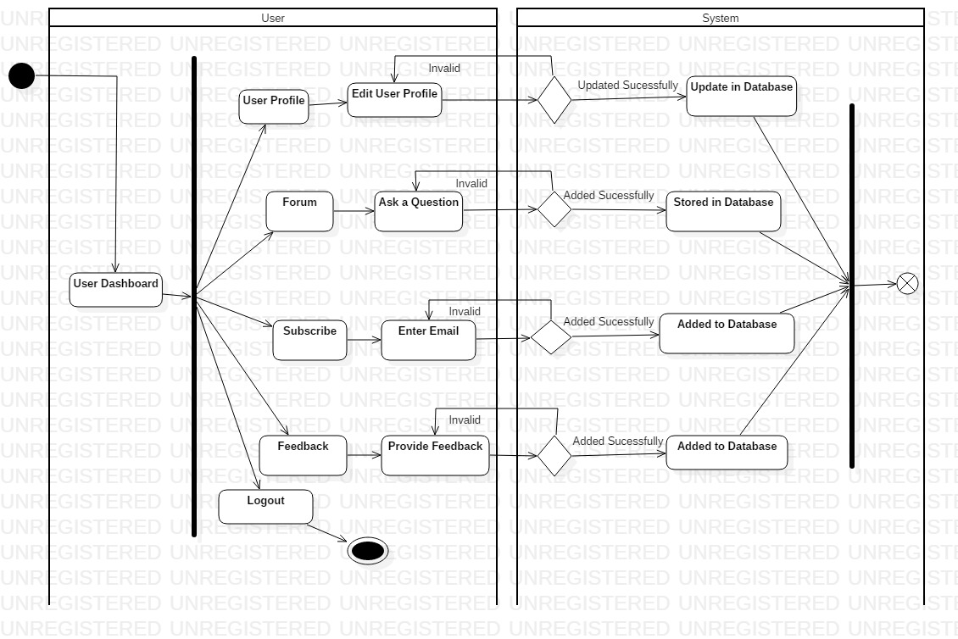

With the user already being logged into the system, the user will be able to edit their profile which will be update in database. They can ask question. The user can subscribe the application by entering their email, and also they can provide feedback.

**User Booking Flight**

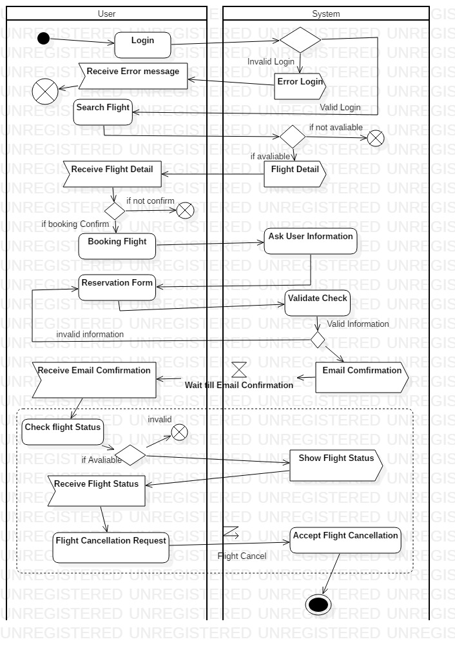

Now the user login into the system with incorrect detail will provide them error message and if the login is correct the user will be taken to their homepage. In homepage they can search for the flight and receive flight detail if it is available. In the booking term, the user can booking flight but for its confirmation the user is asked for their information, fill reservation form where the system will check whether it is valid or not which will provide email confirmation to the user. They can also check flight status if available and also request the system for the flight cancellation.

### **3.2.2 Sequence Diagram**

Sequence diagram is commonly used interaction diagram. It shows the interaction between objects in a sequential order in which the interaction takes place. It also describes how and in what order the objects in a system function.

The importance of performing sequential diagram in my project are as follows:

* It is used to document a requirements of the system and for flushing out the design of system.
* It helps in modelling the flow of logic within a system in a visual manner.
* It also represents the messages that are exchanged between the objects needed for carrying out the functionality.

**Report of notations in Sequence Diagram**

|  |  |  |
| --- | --- | --- |
| **Notation** | **Name** | **Function** |
|  | Actor | Represented by a stick figure, actors are entities that are both interactive with and external to the system. |
|  | Lifeline | A dashed verified line that represents the passage of a time as it extends downward. |
|  | Message Flow | It reflect the start and execution of an operation, or the sending and reception of a signal. |
|  | Focus of Control | It symbolized by a rectangle shape, an activation box represents the time needed for an object to complete a task. |
|  | Alt Combined fragment | It used when a choice needs to be made between two or more message sequences. |
|  | Self-Message | It is indicated with a message arrow that starts and ends at the same lifeline and sends a message to itself. |

**Login and Registration**

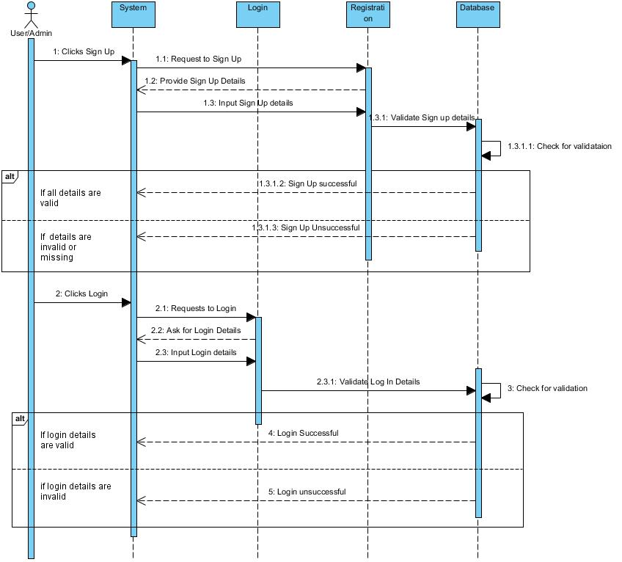

Here, the user will firstly reach for the signup/login form in which after a click on it the system will provide them a form where the user will be filling their details. After the form is filled and submitted, the system will check for the validation in the database. If the validation is correct, the system will sent a message of successful login or successful signup, otherwise the system will sent a message of unsuccessful login or unsuccessful signup if the validation is incorrect.

**Admin Dashboard**

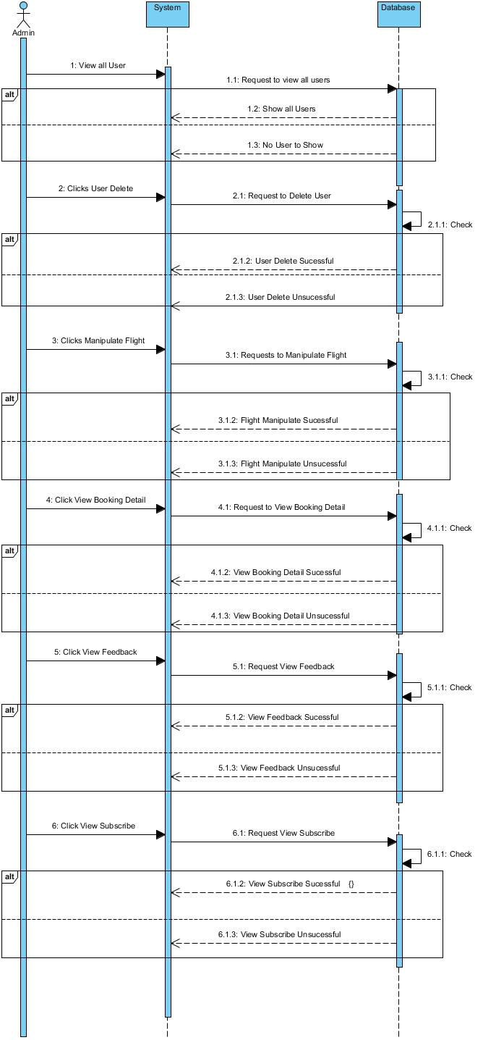

The actions or functions that the admin performed will first be requested by the system to the particular page of the database. And if the page is validate the database will carry out the requested actions and sent the message of actions completed successful else the message of actions completed unsuccessful. All the actions that admin can do is manipulate the flights, view users details and even delete their details, view booking details, view subscribe and view feedback.

**User Dashboard**

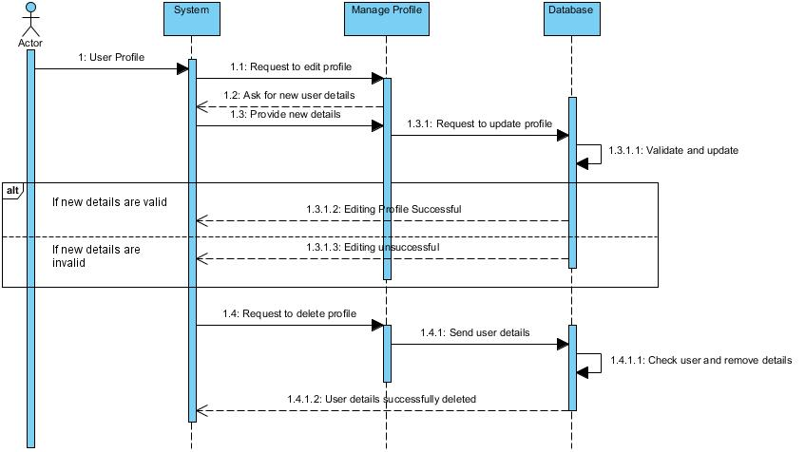

If the user want to perform the action in their profile on editing and deleting then in beginning the users action will be requested by the system to manage profile where the user will be asked for a new user details to enter. The entered details will be sent to database which will be checked for validation and after that the message will be sent as editing profile successful if the validation is correct else editing profile unsuccessful. And in case of deleting the user profile the system will request to the manage profile which will sent user details to the database where user detail will be checked and removed. After the action is completed a message will be sent as user details successfully deleted.

**Booking**

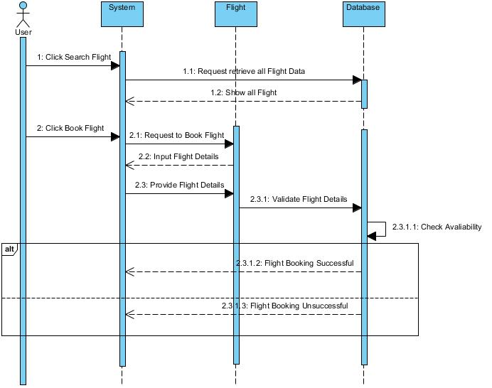

In the booking term, the user will be able to search for a flight and book their flight. The user action will be requested by the system to the flight and then to the database. All the flights will be shown if there is any flight available. When booking the flight system will request to the flight where the user will be asked to input the flight details and the provided flight details will be sent in the database for the validation. If the validation is correct a message will be sent as flight booking successful else flight booking unsuccessful.